Kau, Kylie
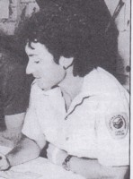
Graduated from Dwellingup cadet school in 1981. Received Keynes Memorial Award. First female cadet. Appointed forest guard 1982. In Busselton 1987, transferred to Bunbury Inventory & Planning. Dieback interpreter in 1989.

